How to Build a Fitness App Like MyFitnessPal or Fitbit?
Focus Keyword: Fitness App Development
Meta Title: Step-by-Step Guide to Building a Fitness App Like Fitbit
Meta Description: Learn how to build a fitness app with tracking, workouts, and health features. Discover costs, key functions, and expert tips for fitness app development.
Feature Image:
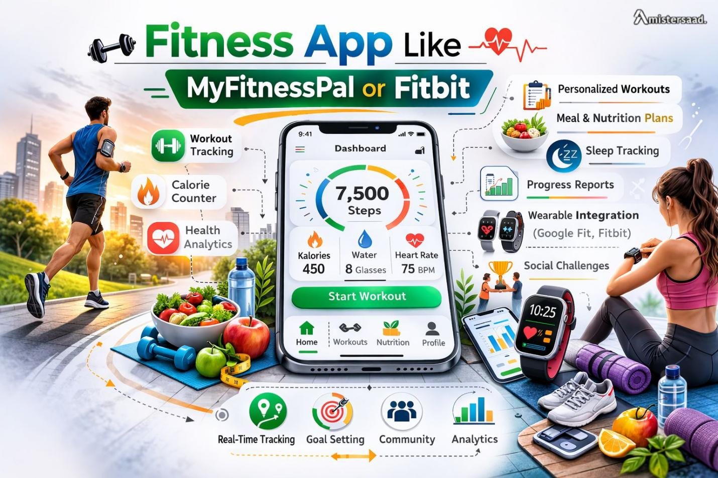
Many users fail to stay consistent with fitness goals. Apps help solve this problem daily. I noticed this while helping wellness startups earlier. People want easy tracking without confusion. Apps like MyFitnessPal changed diet awareness globally. Fitbit simplified daily activity monitoring. A fitness app offers structure and motivation. Users rely on real time health insights. Poor performance causes quick uninstall actions. A well-planned app improves retention rates. This guide explains building a fitness app properly.

Understanding Fitness App User Behavior
User behavior defines app success in fitness platforms. From past projects as a Freelance App Developer Dubai, I learned habits matter most. Users check progress more than features. Beginners need guidance and reminders. Advanced users want deep insights. Morning usage remains higher consistently. Missed streaks reduce motivation fast. Social accountability improves consistency. Feedback loops encourage daily engagement. A skilled App Developer Dubai understands these usage patterns. One app added streak visuals. Daily logins improved within weeks. Understanding behavior reduces churn significantly.

Core Features of a Fitness Tracking App
Feature planning requires real usage awareness. In my experience of mobile app development simplicity always wins. Fitness users avoid complex interfaces. Core tools support daily routines effectively.
• User onboarding with goal setup
• Activity and step tracking
• Nutrition and calorie logging
• Progress charts and reports
• Smart reminders and alerts
A Freelance App Developer Dubai often helps trim excess features. One project removed unnecessary options. User engagement increased noticeably. Focused features save development time. Core functions define long term success.
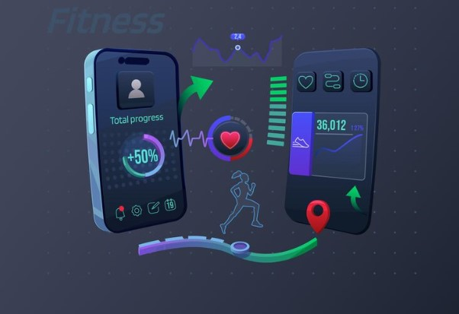

Activity and Workout Tracking System
Workout tracking needs precision and clarity. I helped teams optimize tracking accuracy before. Users expect reliable activity logs. Manual input supports flexibility. Exercise libraries help beginners start easily. Real time stats boost session length. Weekly summaries improve motivation. A Mobile App Developer Dubai builds scalable tracking systems. One app improved sensor calibration. User trust increased after updates. Accurate tracking supports daily fitness habits.

Nutrition and Calorie Tracking Module
Nutrition tracking directly affects fitness results. Many users log meals during busy schedules. Speed and accuracy matter here.
• Food database with portion sizes
• Barcode based food logging
• Daily calorie goal tracking
• Macronutrient breakdown display
A Mobile App Development Dubai team improved food search speed. Meal logging consistency improved. Simple nutrition tools reduce user drop off. Reliable calorie data builds app credibility. Nutrition features support healthier decisions daily.
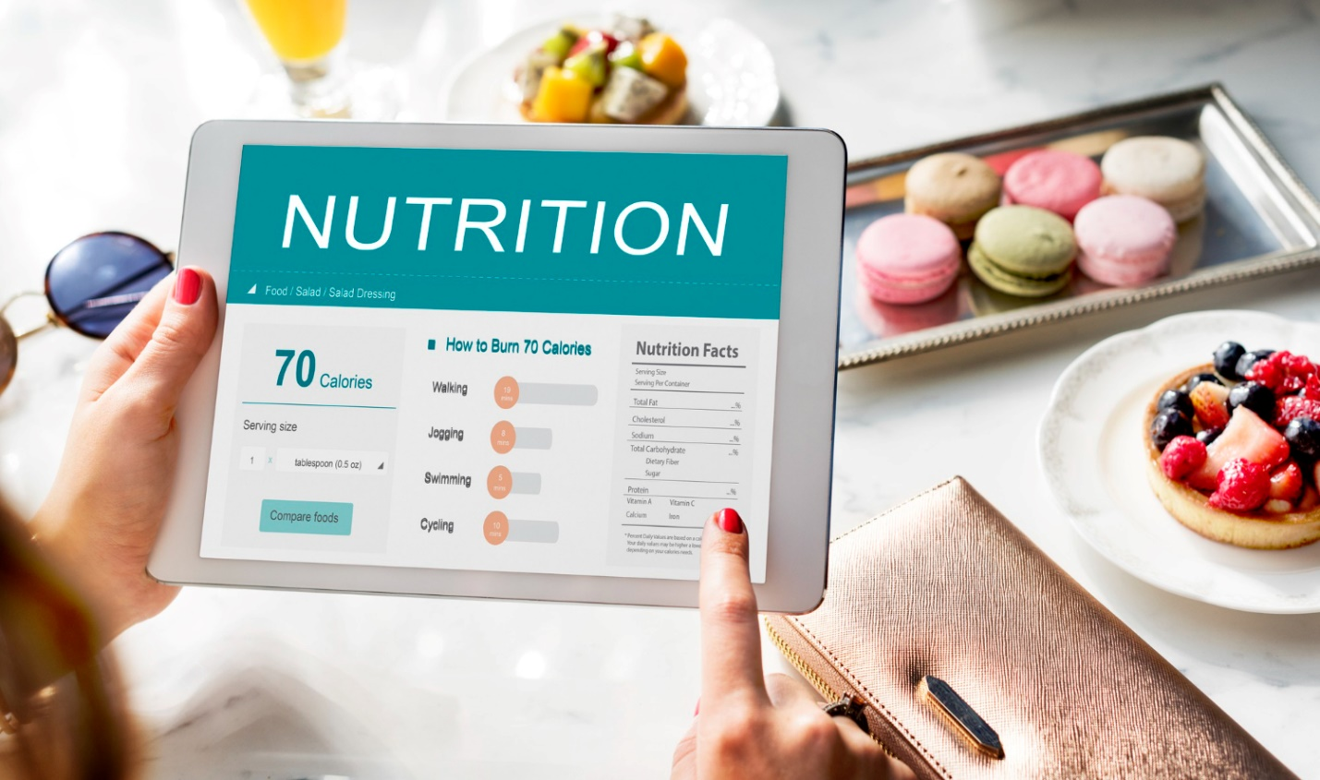

Wearable Device Integration
Wearables add strong value to fitness apps. I worked on several device integrations earlier. Automatic syncing saves user effort. Steps heart rate and sleep data matter. Stable APIs ensure smooth syncing. Sync delays frustrate users quickly. A Freelance Mobile App Development Dubai expert like me always ensures reliability. One app synced with smartwatches smoothly. Manual entries reduced significantly. Wearable support improves data accuracy greatly.

Data Security and User Privacy
Health data requires strict protection always. Users trust apps with sensitive information. Encryption secures stored records. Secure login prevents unauthorized access. Privacy policies must stay clear. Compliance avoids legal issues. One audit fixed hidden security gaps. User confidence improved after updates. Data backups prevent loss. Security focused apps gain long term trust. Privacy builds credibility in fitness platforms.

UI UX Design for Fitness Motivation
Design influences daily user motivation. Clean layouts reduce mental effort. Bright visuals inspire positive behavior. Progress animations reward consistency. Simple navigation keeps focus strong. Dark mode supports night users. I apply insights from twenty-five years’ experience. One redesign increased session duration. Users explored features longer. Motivation driven design improves retention. UX quality impacts habit formation directly.

App Testing and Performance Optimization
Testing ensures smooth daily usage. Fitness apps run constantly in background. Performance issues frustrate users quickly. Load testing ensures stability. Device testing ensures compatibility. Bug fixes improve reliability. One optimization reduced crash rates. App ratings improved after release. Continuous monitoring detects issues early. Optimization supports battery efficiency. Stable performance earns user loyalty.

Conclusion
Building a fitness app needs careful planning. User habits guide development decisions. Strong features support daily routines. Secure systems protect sensitive data. Good design keeps users motivated. Wearable integration adds automation benefits. Testing ensures reliable performance. A well-built app inspires healthy lifestyles. Start your fitness app journey today. Partner with mistersaad who understand users deeply. Contact now to build a trusted fitness platform.

FAQs
How long does fitness app development take?
Usually four to six months based on features.
Can wearable integration be added later?
Yes it can be added anytime.
Is post launch maintenance important?
Yes updates ensure security and performance.
